With Integrated System PRIMEFLEX and Commvault Software, Fujitsu provides convincing solutions to the complex challenges of your converged, hyper-converged, or hybrid-cloud infrastructure such as performance, availability, flexibility, efficiency, security, and data protection.

Data Protection
for Fujitsu Integrated System PRIMEFLEX with Commvault Software
White Paper

Content
1 Introduction – what is in it for you 2
2 Core value proposition of Commvault 2
3 Commvault Software Strategy for data-driven organizations 2
4 Commvault specifics for converged and hyper-converged infrastructure 3
5 Licensing hints – Which software license fits where? 4
6 Our portfolio of data protection appliances for PRIMEFLEX solutions 5
7 Commvault Software features for Fujitsu PRIMEFLEX 7
8 Choosing the right Data Protection Appliance 9
9 Useful Links 10

Introduction – what is in it for you
This white paper for technical decision makers and influencers spans from:
- Stating how we at Fujitsu see our technology alliance partner Commvault.
- Advising which Commvault license options fit what scenario.
- Explaining the difference between target and integrated appliance.
- Describing specifics of Commvault Software for the different converged/hyper-converged infrastructures (CI/HCI) software environments.
- Helping you to classify your data protection requirements and pointing you toward the best fitting appliance.

Core value proposition of Commvault
Apart from the offerings of all newer or longer standing competitors, Commvault customers benefit from the modular character of the software. Advanced functionalities like archiving, data governance, or eDiscovery readiness do not have to be installed as separate software but can be activated simply by purchasing a license key. By using Commvault Intelligent Data Services Platform, the customer gets “one” unique software platform for Backup, Archiving & Management with “one” unique data repository which simplifies localizing & analyzing of all kinds of data. Via the new transparent Command Center GUI, all jobs for Data Administration, Backup Automation, Monitoring & Analysis can be managed efficiently.

Commvault Software Strategy for data-driven organizations
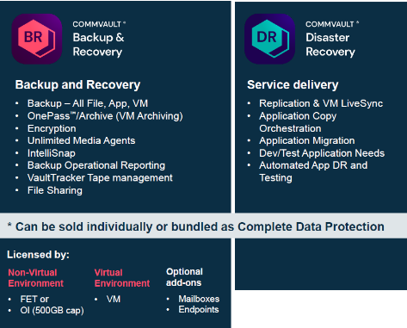
Commvault™ Complete Data Protection suite is a comprehensive, yet easy-to-use data protection solution that combines Commvault Backup & Recovery with Commvault Disaster Recovery. It delivers backup, replication, and disaster recovery for all workloads, on-prem, in the cloud, across multiple clouds, and in hybrid environments. The suite provides trusted recovery of data and applications, virtual machines, and containers, along with verifiable recoverability of replicas, cost-optimized cloud data mobility, security and resilient ransomware protection, and flexible copy data management to leverage protected data for DevOps, testing, and analytics.

All standard Backup & Recovery features are included in the Commvault Complete™ Data Protection licenses, which can be measured either per instance or by capacity (with the details of when to use what explained later). A mix between both licensing options is not possible. To achieve the highest levels of automation, Commvault provides a very useful policy and workflow GUI to streamline operations. This “cockpit” provides peace of mind, as the backup software can identify changes and creation of new instances (e.g., in a database environment) and automatically include this newest data into the backup job. A specific AI engine, which will point the administrator’s attention to every unusual change in the most recently protected data, complements the operation GUI. This helps to prevent the company from the risks of a ransomware attack.
A substantial differentiator towards all other competitors is that the Commvault Backup & Recovery license includes already the archiving of files. Commvault Software can be licensed using either Front-End Terabytes (FET) or per VM or per operating instance (OI). Commvault Backup & Recovery can be licensed per User for Mailbox Archiving & Endpoint Protection.

Commvault Software Add-on modules depending on your needs
Customers can exceed Commvault Complete™ Data Protection software by purchasing additional license keys for the following add-on software modules:
- Commvault HyperScale™ X Software is an intuitive scale-out solution that’s fully integrated with Commvault’s Intelligent Data Services Platform. The technology enables an on-premises scale-out backup and recovery infrastructure delivering “Cloud-like” scale, cost, and flexibility. It can be added to manage a highly available and easy scalable architecture - available also as a fully integrated appliance or as a reference design using the customer’s preferred storage hardware vendor. The preferred licensing is based on a three-to-five-year subscription model that includes maintenance for hardware and software and allows a hardware refresh without any downtime with a subscription renewal.
Learn more: https://www.commvault.com/hyperscale/
- Several solutions like Commvault Data Governance, Commvault eDiscovery & Compliance or Metallic as-a-service can expand the standard feature set of Commvault Complete Data Protection. Intelligent data services support customers in identifying and analyzing data that may include Personally Identifiable Information PII (like passport data, credit card details, etc.) which could be affecting GDPR legal compliance.
Learn more: https://www.commvault.com/intelligent-data-services

Commvault specifics for converged and hyper-converged infrastructure
A comprehensive list of supported technologies
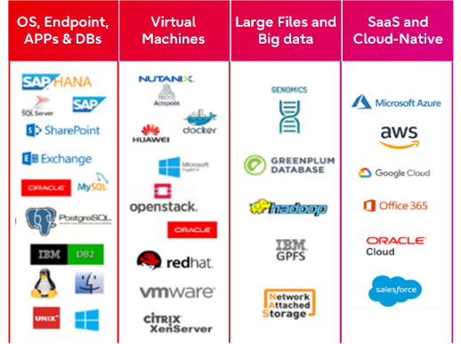
Commvault’s capability across modern and traditional environments and its full integration in cloud environments and the huge number of supported hypervisors make it a perfect fit for protecting hybrid environments:
- 18 hypervisor, container, Kubernetes platforms
- 30+ integrated storage and HCI types for snap and replication
- 25 application and database types
- 20+ operating environments
- SaaS (Software-as-a-Service) application coverage for Office 365, Salesforce, and more

See a detailed list on: https://www.commvault.com/supported-technologies

Easy licensing for virtual environment
The customer can license per number of VMs running on the frontend by purchasing packages of 10 VMs each.
Analyzing the value of data is more important than ever
What kind of data do I have and where? How can I save (license) costs? Data insights enables organizations to apply machine learning and artificial intelligence (AI/ML) to drive insights from their data. It helps to optimize operations and to control and manage on-premises or cloud growth. Especially prior to moving data to the cloud, stale and unwanted data should be identified and sorted out.
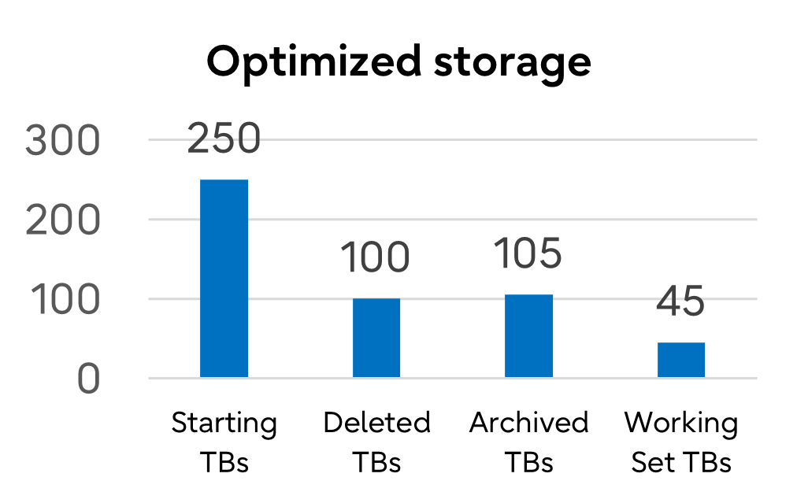
Analysis will deliver the following:
- Understand where data is stored
- Identify duplicate data
- Identify orphaned data
- Identify outdated data
- Identify data to be protected
- Identify data to be archived/preserved

Licensing hints – Which software license fits where?
Define your data growth scenario – is it predictable, progressive, or volatile?
The classification of data growth implies what kind of solution is the right balance between flexibility and cost.
- Predictable & stable data growth allows easier planning for the next 3-5 years and regularly adding some more capacity.
- Progressive data growth is rising exponentially or abruptly. Fast and simple scalability in capacity and performance is required.
- Volatile (positive/negative) data growth due to regularly changing needs and a fluctuating data amount requires highest levels of flexibility.

Commvault offers two payment options: Perpetual or Subscription?
A general differentiation between the two is the following:
- Perpetual licensing (buying) counts as CapEx on the balance sheet.
- Subscription licensing (renting) counts as OpEx and lowers profit.

However, it is worth to bring it in context of data growth scenarios.
- For a “predictable” growth scenario, a perpetual licensing makes perfect sense, because the license usage period is unlimited, and licenses can be added when required. The maintenance period is extendable and priced in percentage of the original license price.
- For a “volatile” growth scenario, subscription licensing on yearly basis (incl. also maintenance) provides the flexibility to reduce both license & maintenance costs in case of data reduction.
- With a “progressive” data growth scenario, there is not any data reduction expected, but it is worth considering subscription licensing for the following reasons:
- Always up to date: with latest innovations, no conversions needed
- Room for negotiation: not trapped in fixed maintenance contracts
- Easy calculation & extension: maintenance is included
- Flexible license periods and quantity - add or reduce license quantities more easily, purchase on purpose, no “stockpiling”

Our portfolio of data protection appliances for PRIMEFLEX solutions
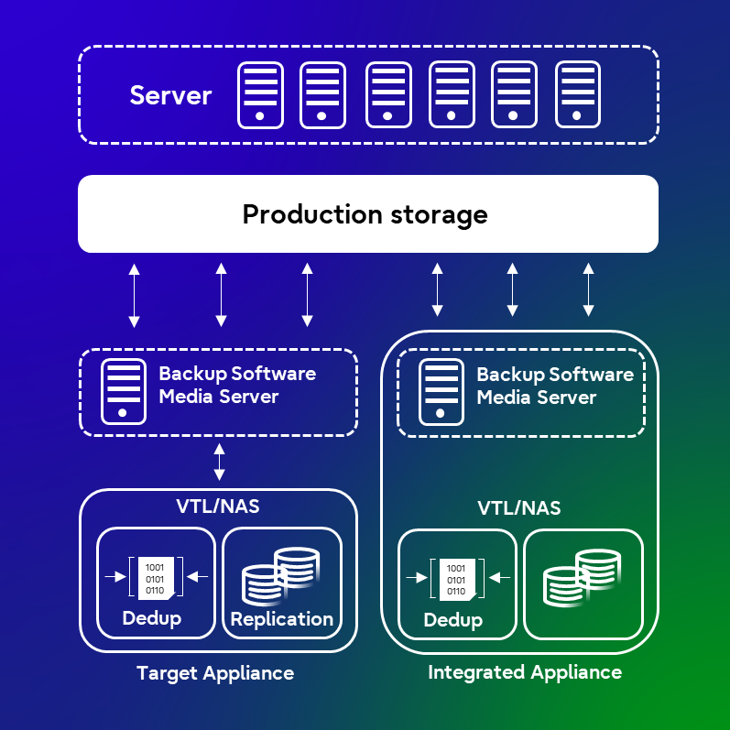
Differences between target appliance versus integrated appliance:
- Target Appliances require a separate backup server and software.
- Integrated Appliances include tightly coupled software, hardware, and support in a single package

Fujitsu ETERNUS CS800 is a target appliance for backup
ETERNUS CS800 is a turnkey, easy to operate, backup-to-disk Appliance supporting all market-relevant backup suites.
- Leading deduplication technology reduces disk capacity by up to 95%, saving tremendous storage and environmental cost.
- Deep integration of the Commvault Media Agent (data movers) reduces additional investment costs.
- Disaster Recovery capabilities through optimized replication (NAS and VTL) protects your business-critical data ensuring business continuity.
The ETERNUS CS800 fits best for
- backup of PRIMEFLEX environments in branch offices, for small, medium, and upper medium customers.
- daily backups starting small and ranging up to 50 TB per day (depending on use case).

Fujitsu ETERNUS CS8000 is a target appliance for backup and archiving
ETERNUS CS8000 is a reliable data center solution for enterprise backup and archiving for mainframe and open systems providing a central repository for backup, archive, second tier and object data.
- The Fujitsu ETERNUS CS Software offers intelligent automation features and relieves admins from workload, ensuring higher and more reliable service levels.
- Advanced VTL features (e.g., dual or triple safe, cache mirror, etc.) which can be combined with the capabilities of the Commvault software can lead to huge TCO reductions in complex backup environments.
- WORM functionality enables compliant archiving and thwart cyberattacks with immutable storage.
- No other data protection appliance in the market allows customers to design a synchronous replication architecture between two data centers.
- One of the highly appreciated features of the software is a function called “Tape refresh,” which automatically handles necessary transitions from older to newer tape media and robotic technology.
- Two features that were developed by Commvault specifically for the ETERNUS CS8000 are:
- VTL - Prefetch: In the event of a recovery or AUX copy, Commvault Software checks the virtual volumes required for the job and, if necessary, automatically initiates a graduated remigration to the cache in advance.
- VTL - Scratch Mount: If Commvault Software wants to use an expired tape again, the software automatically sends the information that the data of the virtual tape is invalid and does not have to be retrieved into the cache again.
The ETERNUS CS8000 is ideally suited for:
- upper medium and large enterprises to protect data from edge-core-cloud.
- service providers due to flexible “Scale” and “Growth” on-demand purchasing options.
- daily backup larger than 50 TB.
- customers with challenging backup and archiving SLAs like the need to support multiple media types or design an architecture with no single point of failure.
- data-driven organizstaion to support large amounts of data ranging up to 60 Petabytes disk cache plus virtually unlimited capacities on tape media.
- thwarting ransomware with an 3-2-1 approach combining backup and archive to disk and tape.
- for heterogeneous environment with open systems and mainframes. ETERNUS CS8000 uses one software GUI for handling the backup data of mainframe and open system (e.g., x86, VMs, Unix, etc.).

Fujitsu Reference Architecture provides a validated reference design for Commvault environments
- The Fujitsu Reference Architecture for Commvault® HyperScale™ X Software brings the benefits of the cloud - in terms of service, agility, resilience, scale, and cost - to on-premises backup storage.
- The data protection solution is based on pre-tested configurations and built with Commvault HyperScale™ X Software and Fujitsu PRIMERGY servers enabling organizations to build a unified, modern data protection and management platform on a scale-out infrastructure.
- Customers gain a fully tested, easy-to-set-up data protection solution for backing up and archiving data in physical, virtual, or cloud-based data centers.
The Reference Architecture is the data protection solution for:
- medium up to very large enterprise customers and service providers.
- larger scale environments with high performance and capacity demands.
- daily backup larger than 50 TB (depending on use case).

Commvault Remote Office Appliance 1200 is an integrated appliance for remote or branch offices
- As part of a Commvault environment or as a standalone solution, it allows customers to address the challenges of supporting remote and branch offices.
- The Remote Office Appliance is a 1HU (rack height unit) server, that may be deployed as a CommServe + Media Agent or as a Media Agent only configuration.
The Commvault Remote Office Appliance fits best
- to protect, access, and use all your data wherever it exists, from remote offices to corporate offices and into the cloud.
- to protect data locally and may be centrally managed to alleviate the need for local IT staff.

Commvault HyperScale X Appliance is an integrated appliance for backup and archiving
- The appliance brings the benefits of the cloud - in terms of service, agility, resilience, scale, and cost - to on-premises backup storage.
- Hyper-converged infrastructure starting with three clustered nodes (forming a “block”) - and easily scaling out node by node, adding both performance and capacity.
- The appliance works on the Commvault Complete™ Data Protection license scope - all available add-ons work as well when licensed.
- It is attractive to purchase the solution as a subscription model (hardware & software combined), because at the end of the subscription license period, customers choosing a “renewal” will receive new hardware at no extra cost.
- The nature of the hyper-converged technology then allows for a no-downtime hardware-refresh on premise with data-in-place.
The Commvault HyperScale Appliance is ideally suited for:
- medium and large enterprise customers and service providers.
- daily backup larger than 50 TB (depending on use case).
- data-driven enterprises with high data growth and always-on business. The scale-out architecture enables an easier way to true scalability for very flexible data growth, by adding both storage capacity and compute power in one instance. The appliance offers high availability with erasure coding where a full node can be recovered.

For more details about our joint Commvault portfolio please refer to the webpage.

Commvault Software features for Fujitsu PRIMEFLEX
What makes Commvault a perfectly fitting data protection solution for Fujitsu Integrated System PRIMEFLEX environments?

PRIMEFLEX for Microsoft Storage Spaces Direct and Azure Stack HCI are solutions for Microsoft applications
- Commvault provides agentless protection of Storage Spaces Direct VMs through native Storage Spaces Direct APIs, using the Commvault Virtual Server Agent (VSA).
- Application-consistent protection helps to ensure that your VMs — and your applications are adequately protected and fully recoverable.
- Azure Stack snapshot integration and orchestration through Commvault IntelliSnap® enables faster backup and recovery.
- Commvault supports easy conversion and migration of VMs from other hypervisors to Storage Spaces Direct.
- Disaster Recovery of VMs from one Storage Spaces Direct to another Storage Spaces Direct.

PRIMEFLEX for Nutanix Enterprise Cloud simplifies the deployment across edge-core-cloud
Commvault protects virtual machines that are hosted on Nutanix cluster. You can configure a hypervisor to represent the Nutanix cluster. The key features are:
- Backup virtual machines, with an option to perform application-aware backups.
- Restore guest files and folders or full virtual machines.
- Convert VMs to a different virtualization platform.
- Replicate VMs for disaster recovery, with orchestration for failovers and failbacks.
- You can configure a Nutanix AHV hypervisor to perform IntelliSnap backups. From the snap or backup copy, you can restore full instances and restore guest files and folders.
Specifics of Commvault software for Nutanix Files
- Enables “Incremental Forever” data protection of CIFS- or NFS-based Files data, leveraging the Changed Files Tracking (CFT) API of Nutanix Files data
- Enables end-user self-service recovery, tightly integrated with Active Directory through a simple, intuitive web-based management portal
- Provide consolidated reporting and monitoring for multiple Nutanix Files environments
- Single licensing model can cover all Nutanix Files environments within an enterprise

Cloud integration enables true hybrid backup and restore infrastructures to:
- integrate directly cloud storage and resources without the need for costly gateways.
- leverage cloud resources as primary or secondary backup storage.
- recover directly from cloud resources without the need to stage data.

Commvault is best for VMware vSphere and vSAN because of:
- agentless protection of VMware VMs, with automatic application-aware consistency when required.
- “Incremental forever” data protection strategy, using Change Block Tracking (CBT) technology.
- the support of application-consistent protection.
- built-in compression and global deduplication across all virtual machines.
- virtual machine migrations and conversions to and from Microsoft Hyper-V.
- full integration with VMware APIs and SDKs - VADP (VMware API for DataProtection), VAIO (VMware API for IO Filtering) and VDDK (VMware Virtual Disk Development Kit).
- policy-driven architecture supports Service Level Agreements (SLAs) for backup and disaster recovery through accurate dashboard reporting.
- comprehensive Disaster Recovery support, including planned and unplanned failover, failback, and DR testing (with Commvault Live Sync).
- automatic discovery using VM Name/Pattern, Host, Datastore, Guest OS, Power State, Notes, Custom Attribute, Tags, and Categories.
- VM Lifecycle Management including archiving of VMs.
- Live Sync for VMs (1:1 VMs aka single instances) is included in Complete Backup & Recovery license. Commvault Disaster Recovery would be necessary if the customer requires database-level Live Sync, or any kind of multi-server orchestration (Failover Groups vs. simply VM-to-VM failover).
- merging on-premises and multi-cloud operations by using IntelliSnap Protection which is available for VMs on vVol or vSAN data stores.
- vCloud backup and restore for virtual machines in a vCloud data center is supported >> vCloud Director 9.5+ Support.
- support of VMware Cloud on AWS: Certified VM conversion from VMware to Amazon format, Live Sync replication, and Live Sync Direct for snapshot-based replication (with the flexibility to use the VMware or storage hardware vendor snapshot as the basis for replication).

Commvault solutions for Containers and more
- Commvault provides agentless backup and supports in-place and out-of-place restores for Docker containers and images.
- Commvault does not require intrusive installation on Docker hosts. A virtualization client is the access point for Docker.
- When creating a Docker virtualization client, the Commvault software automatically creates a Docker instance, a backup set, and a default sub-client that can be used to protect all containers and images.

Commvault has decided to strategically invest to better support OpenStack and Kubernetes environments. This decision is underpinned by the good news, that Commvault now supports agentless operations for RedHat OpenShift, Alibaba, Oracle Cloud. Containerization platforms are really seen as the game changers in terms of enterprise adoption. They create the structures that allow for engineering teams to collaborate and bring in the scaffolding for orchestration as well as on-demand consumption.
You can use the Commvault software to backup, restore, and migrate stateful Kubernetes applications and data.

Commvault supports SAP solutions
The Integrated System PRIMEFLEX for VMware vSAN and PRIMEFLEX for Nutanix Enterprise Cloud are certified for SAP HANA. Commvault software provides a simplified end-to-end backup and recovery solution for SAP environments. It uses the SAP Backint interface program (certification: Backint for SAP HANA) to back up the data directly to the attached media. In case of a data loss due to hardware failure, natural disaster, accidental deletion, or corruption of data, you can restore the backed-up data and the log files directly from the media using the SAP Backint interface program. This reduces complexity, human intervention, and the risk of data loss.
More details see: Commvault documentation: Databases - SAP

For more technical information please refer to Commvault BooksOnline documentation

Choosing the right Data Protection Appliance
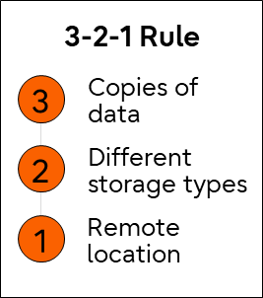
Backup rules & scenarios
A general backup rule is the 3-2-1 rule:
- 3 data copies
- 2 different media types (disk/tape/cloud)
- 1 offsite location (cloud/vault site)

Depending on the relevance & value of data, backup rules can be classified into different scenarios, like the
following: Bronze, Silver & Gold. These classifications are differentiating between SLA and number of copies,
media types, and location to guarantee the required level of data protection. Sometimes customers design
their complete backup & restore environment to bronze, silver, or gold level, sometimes they use different
levels for different locations – sometimes they look to reduce the types of media, sometimes they add one – it is all possible and, in many cases, even reasonable to do so.
We have created the graphic below is for you to quickly find a way to categorize your requirements and to then find your way to the right appliance. This, of course, only to be seen as a starting point of the consultative dialogue, which would have to follow up after you have read this technical white paper.

What appliance fits best for your environment
Commvault data protection software can of course also be installed on a standard Fujitsu PRIMERGY Server with internal mass storage or combined with an external Fujitsu JX DAS Storage and/or ETERNUS AF all-flash or ETERNUS DX hybrid storage. The reason to use an integrated or a target appliance is the deeper level of integration and the better support structure for the whole solution. The Fujitsu Storage ETERNUS LT family and the high-scale tape libraries from our long-standing technology partner Quantum leverage a broad tape storage portfolio.
The graphic below shows recommendations for the perfect use of the data protection appliances based on the classification levels bronze, silver, and gold. Choose the appliance which fits best for your required SLAs:

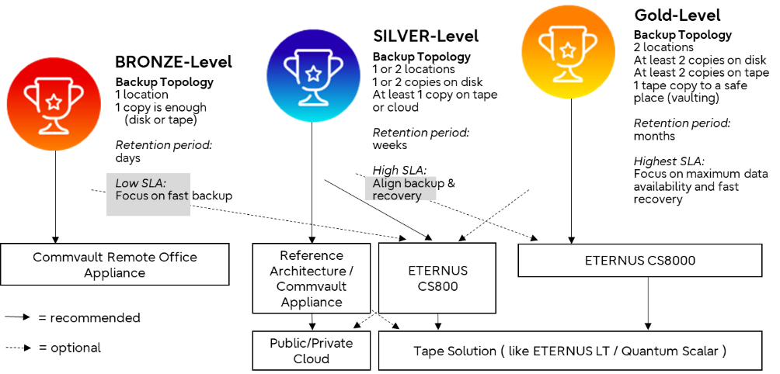

Useful Links
- Analyst report: Freeform Dynamics: Protecting data in your hyper-converged environment
- Data Protection Video (general): How to protect your business-critical data
- White Paper: Data Protection for the Digital World
- Use Case White Paper: Data Protection for Nutanix

Contact us

to find out we can help you to protect your data in your hybrid environment
to ensure 24/7 business continuity.

Contact  Fujitsu Technology Solutions GmbH  Mies-van-der-Rohe-Strasse 8  D-80807 Munich  Internet: www.fujitsu.com/dataprotection  Date: 2022-06-28 ww-en | © Fujitsu 2022. All rights reserved. Fujitsu and Fujitsu logo are trademarks of Fujitsu Limited registered in many jurisdictions worldwide. Other product, service and company names mentioned herein may be trademarks of Fujitsu or other companies. This document is current as of the initial date of publication and subject to be changed by Fujitsu without notice. This material is provided for information purposes only and Fujitsu assumes no liability related to its use. FUJITSU-PUBLIC

